Brainstorm

& idea prioritization

Use this template in your own brainstorming sessions so your team can unleash their imagination and start shaping concepts even if you're not sitting in the same room.

## Before you collaborate

#### A little bit of preparation goes a long way with this session. Here’s what you need to do to get going.

##### 10 minutes

###### Team gathering

Define who should participate in the session and send an invite. Share relevant information or pre-work ahead.

###### Set the goal

Think about the problem you'll be focusing on solving in the brainstorming session.

###### Learn how to use the facilitation tools

Use the Facilitation Superpowers to run a happy and productive session.

**1**

## Define your problem statement

#### What problem are you trying to solve? Frame your problem as a How Might We statement. This will be the focus of your brainstorm.

##### 5 minutes

Thyroid nodules: includes begin and malignant nodules.

**PROBLEM**

**How might we [your problem statement]?**

**2**

## Brainstorm

#### Write down any ideas that come to mind that address your problem statement.

##### 10 minutes

###### Person 1

Thyroid disease cases to classify patients based on their symptoms, lab results, and other factors.

Genomics have identified several genetic markers that are associated with thyroid disease,

**Person 2**

Telemedicine; Telemedicines allows patients to consult with doctors remotely.

This can improve acces to healthcare for people.

**3**

## Group ideas

**TIP**

You can select a sticky note and hit the pencil [switch to sketch] icon to start drawing!

#### Take turns sharing your ideas while clustering similar or related notes as you go. Once all sticky notes have been grouped, give each cluster a sentence-like label. If a cluster is bigger than six sticky notes, try and see if you and break it up into smaller sub-groups.

**20 minutes**

# 

Thyroid disease classification can be based on the different factors.

Here are some group ideas for thyroid disease classification,

1. Based on cause: Autoimmune thyroid disease it includes

Hashimoto's thyroiditis and Graves' disease.

Iodine dificiency disorders: includes goiter and cretinism.

**4**

## Prioritize

#### Your team should all be on the same page about what's important moving forward. Place your ideas on this grid to determine which ideas are important and which are feasible.

**20 minutes**

## After you collaborate

You can export the mural as an image or pdf to share with members of your company who might find it helpful.

**Quick add-ons**

###### Share the mural

**Share a view link** to the mural with stakeholders to keep them in the loop about the outcomes of the session.

###### Export the mural

Export a copy of the mural as a PNG or PDF to attach to emails, include in slides, or save in your drive.

**10 minutes** to prepare

**1 hour** to collaborate

**2-8 people** recommended

[**Open article**](https://support.mural.co/en/articles/2113740-facilitation-superpowers)

Thyroid strom is a life threatening condition by an excessive release of thyroid

hormones.

incorping this information into a classification system could improve accuracy.

It may enable earlier detection and treatment of thyroid disease.

This can helps to people of underserved areas.

### Key rules of brainstorming

Myexdema coma is a rare but serious condition that can occur in people with untreated or poorly managed hypothyroidism.

To run an smooth and productive session

genomics is the treatment of thyroid is personalized

Hyperthyroidism is a overactivethyroid.

2. Based on the level of the thyroid hormone production,

Eurothyroidismis a normal thyroid

.

Hypothyroidism is a underactive thyroid.

treatment.

### Keep moving forward

###### Strategy blueprint

Define the components of a new idea or strategy.

###### [Open the template](https://app.mural.co/template/e95f612a-f72a-4772-bc48-545aaa04e0c9/984865a6-0a96-4472-a48d-47639307b3ca)

**Customer experience journey map**

Understand customer needs, motivations, and

Stay in topic. Defer judgment.

Encourage wild ideas. Listen to others.

### Importance

Acquired thyroid disease)(devel ops later in life)

Congenital hypothyroid(presen t at birth)

3. Based on the age of

onset,

If each of these

obstacles for an experience.

[**Open the template**](https://app.mural.co/template/b7114010-3a67-4d63-a51d-6f2cedc9633f/c1b465ab-57af-4624-8faf-ebb312edc0eb)

Graves' disease is an autoimmune disorder that causes the thyroid gland to produce too much thyroid hormone.

Go for volume. If possible, be visual.

###### Person 3

**Person 4**

tasks could get

done without any difficulty or cost, which would have the most positive impact?

###### Strengths, weaknesses, opportunities & threats

Identify strengths, weaknesses, opportunities, and threats (SWOT) to develop a plan.

Thyroid nodules are lumps are growth in the thyroid gland that are usually begin but sometimes be cancerous.

|  |  |
| --- | --- |
|  |  |
|  |  |

###### [Open the template](https://app.mural.co/template/6a062671-89ee-4b76-9409-2603d8b098be/ca270343-1d54-4952-9d8c-fbc303ffd0f2)

[**Share template feedback**](https://muralco.typeform.com/to/CiqaHVat?typeform-source=app.mural.co)

Hypothyroidism is a condition in which the thyroid gland does not produce enough thyroid hormone. It can cause symptoms such as fatigue, wieghtgain and depression.

over thyroid (abnormal thyroid functions tests with symptoms)

subclinical thyroid disease(abnormal but no symptoms)

4. Based on the severity

of symptoms,

This approach could involve endocrinologists, radiologists, pathologists, and other specialists.

It improve accuracy and reduce the likellihood of misdiagnosis.

This tools such as mobileapps, could be developed to help patients.

Patient self- assessment tools.

It used to track their symptoms, medication usage.

This information could then be used improve could then be used to improve classification.

Collaborative diagnosis approach.

In which doctors work together to diagnose and treat patients.

5. Based on the imaging

findings,

Thyroiditis(inflammation of the thyroid gland)

Thyroid nodules(solid or cystic growths in the thyroid gland gland)

Diffuse thyroid enlargement (enlarged thyroid gland with uniform appearnace)

Hyperthyroidism is a condition which the thyroid gland produces too much thyroid hormone, It can cause symptoms such as weight loss, rapid heartbeat, and anxiety.

[**Share template feedback**](https://muralco.typeform.com/to/CiqaHVat?typeform-source=app.mural.co)

### Feasibility

Regardless of their importance, which tasks are more feasible than others? (Cost, time, effort, complexity, etc.)

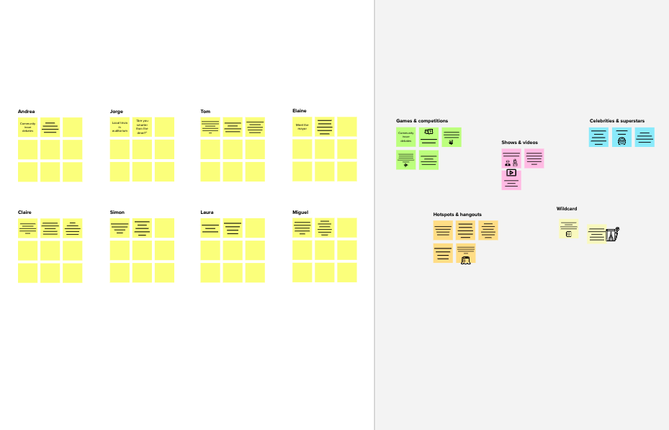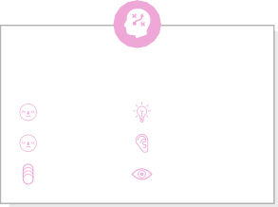

**Template**

**Need some inspiration?**

See a finished version of this template to kickstart your work.

[Open example](https://app.mural.co/template/e5a93b7b-49f2-48c9-afd7-a635d860eba6/93f1b98d-b2d2-4695-8e85-7e9c0d2fd9b9)

|  |  |  |  |  |
| --- | --- | --- | --- | --- |
|  |  |  |  |  |
|  |  |  |  |  |